

**Project Synopsis Report**

***On***

## Door to Door Services

#### (CS VI Semester project BCP-601) 2020-21



**Submitted to: Submitted by:**

**Dr. Naveen Tiwari** Charanjeet Singh Sidhu Gitesh Adhikari

Associate Professor

Department of CS/IT

GEHU, Bhimtal

(BSc. IT)

(BCA)

**Guided by:** Deepak Kumar

(BCA)

Dr. Sudhanshu Maurya Vijay Bhatt

Assistant Professor

Department of CS/IT

GEHU, Bhimtal

(BCA)

**DEPARTMENT OF COMPUTER SCIENCE AND ENGINEERING**

**GRAPHIC ERA HILL UNVERSITY, BHIMTAL**

**CERTIFICATE**

Certified that **Charanjeet Singh Sidhu** (Roll No.- 2072022), **Gitesh** **Adhikari** (Roll No.- 2071351), **Deepak** **Kumar** (Roll No.- 2071360) and **Vijay Bhatt** (Roll No.-2071396) have submitted project synopsis report on “Door to Door Services” for the CS VI Semester Project Lab (BCP-601) in Graphic Era Hill University, Bhimtal under my supervision. The project carried out by Students is their own work as best of my knowledge.

Date: 06-JUNE-2021

(**Dr. Sudhanshu Maurya**)

Project Guide Assistant Professor Department of CS/IT GEHU, Bhimtal



## PROJECT DESCRIPTION

#### About Project

In today’s life everyone is busy with their work and sometimes they don’t

have enough time to visit stores or meet the person who can solve their

issues.

So, we are here.

Our motto will help you to bring

##### YOUR IMAGINATION TO YOUR DOORSTEP.

This website will help you to get your daily needs at your doorstep. Even

small to small services are available in it.

In this website you will be getting services like:

* Transport/Courier Service
* Product Delivery
* Grocery
* Technical Helper/ Adviser
* Electrician
* Cleaner
* Gardening
* Baby Sitting
* Food Order
* Event Management
* Healthcare/ Nursing
* Home Tutor
* Mechanical Helper/ Adviser

#### 1.1Requirement of Project

##### 1.1.1Hardware Requirement

* + - * Laptop or Desktop with Configuration
        + Main Memory (RAM 1gb and above)
        + Primary Memory (ROM 500gb and above)
      * Processor Intel core Processor ™ Duo
      * Hard Disk Utilization :2.80 GHz
      * External Hard Drive or DVDs for Backup. ...
      * Camera.
      * Server.
      * Mobile Devices.

##### 1.1.2Software Requirement

* Operating System: Windows, Mac Os or Linux
* Front End
  + Notepad, Vs code or Notepad ++ (To code Html and CSS)
  + Adobe Photoshop (For Image Editing)
* User Interface
  + Notepad, Vs code or Notepad ++ (To code JavaScript)
* Backend
  + Node JS and Mongo DB (To design Backend)
  + SQL (For table Designing in Backend)
* To implement the final Project Browser
  + Google Chrome (vast used is Google Chrome for our Project)
  + Firefox
  + Internet Explorer
  1. **1.1.3 Name and Logo of the Project**

**Name**

# DOOR TO DOOR SERVICES



**LOGO**

**Tagline**

# YOUR IMAGINATION TO YOUR DOOR STEPS

### 1.2Modules of Project

* + 1. **1.2.1 Module 1:**
* **Creating website using HTML 5, provides hyperlink and hypertext**
* **Designing through CSS 2.1 includes presentation of web-pages, coloring, layouts, and web fonts.**
* **Designing a responsive web site using CSS-flex box for creating a modern website**
* **Using CSS-grid for layouts both columns and rows**
* **Use of ultra-specific textual elements**
* **Design by Charanjeet Singh Sidhu**
  + 1. **1.2.2 Module 2:**
* **Provides user interactive and interface by adding web pages behaviour using JavaScript ES6**
* **Creating sites and web apps that rendering on client’s sides**
* **Using AJEX, for updating the webpage without reloading the page, request and receive data from the server**
* **Update user interface by DOM-API**
* **Includes animated bullets lists, responses scaling and a wide variety of features**
* **Design by Deepak Kumar and Vijay Bhatt**
  + 1. **1.2.3 Module 3:**
* **Backend development and building web server using Node JS 14.x**
* **Making updates and changing in addition to monitoring functionality of the site**
* **Content on the site is constantly changing and updating**
* **Manage hosting environment, accessibility and security compliance**
* **Create methods for render on the server sites**
* **Queries database for information and processing any logic**
* **Design by Gitesh Adhikari**
  + 1. **1.2.4 Module 4:**
* **Database development using Mongo dB 4.4.4**
* **Store user related data, such as mail, username, id(generates while registration), shipping details, history**
* **Provide verification of user while registration**
* **Session management**
* **Design by Gitesh Adhikari, Deepak Kumar, Charanjeet Singh Sidhu**

##### 1.3Any other relevant information like (E-R Diagram, DFD etc)

* + 1. **1.3.1 Blue Print of the Homepage of the website**

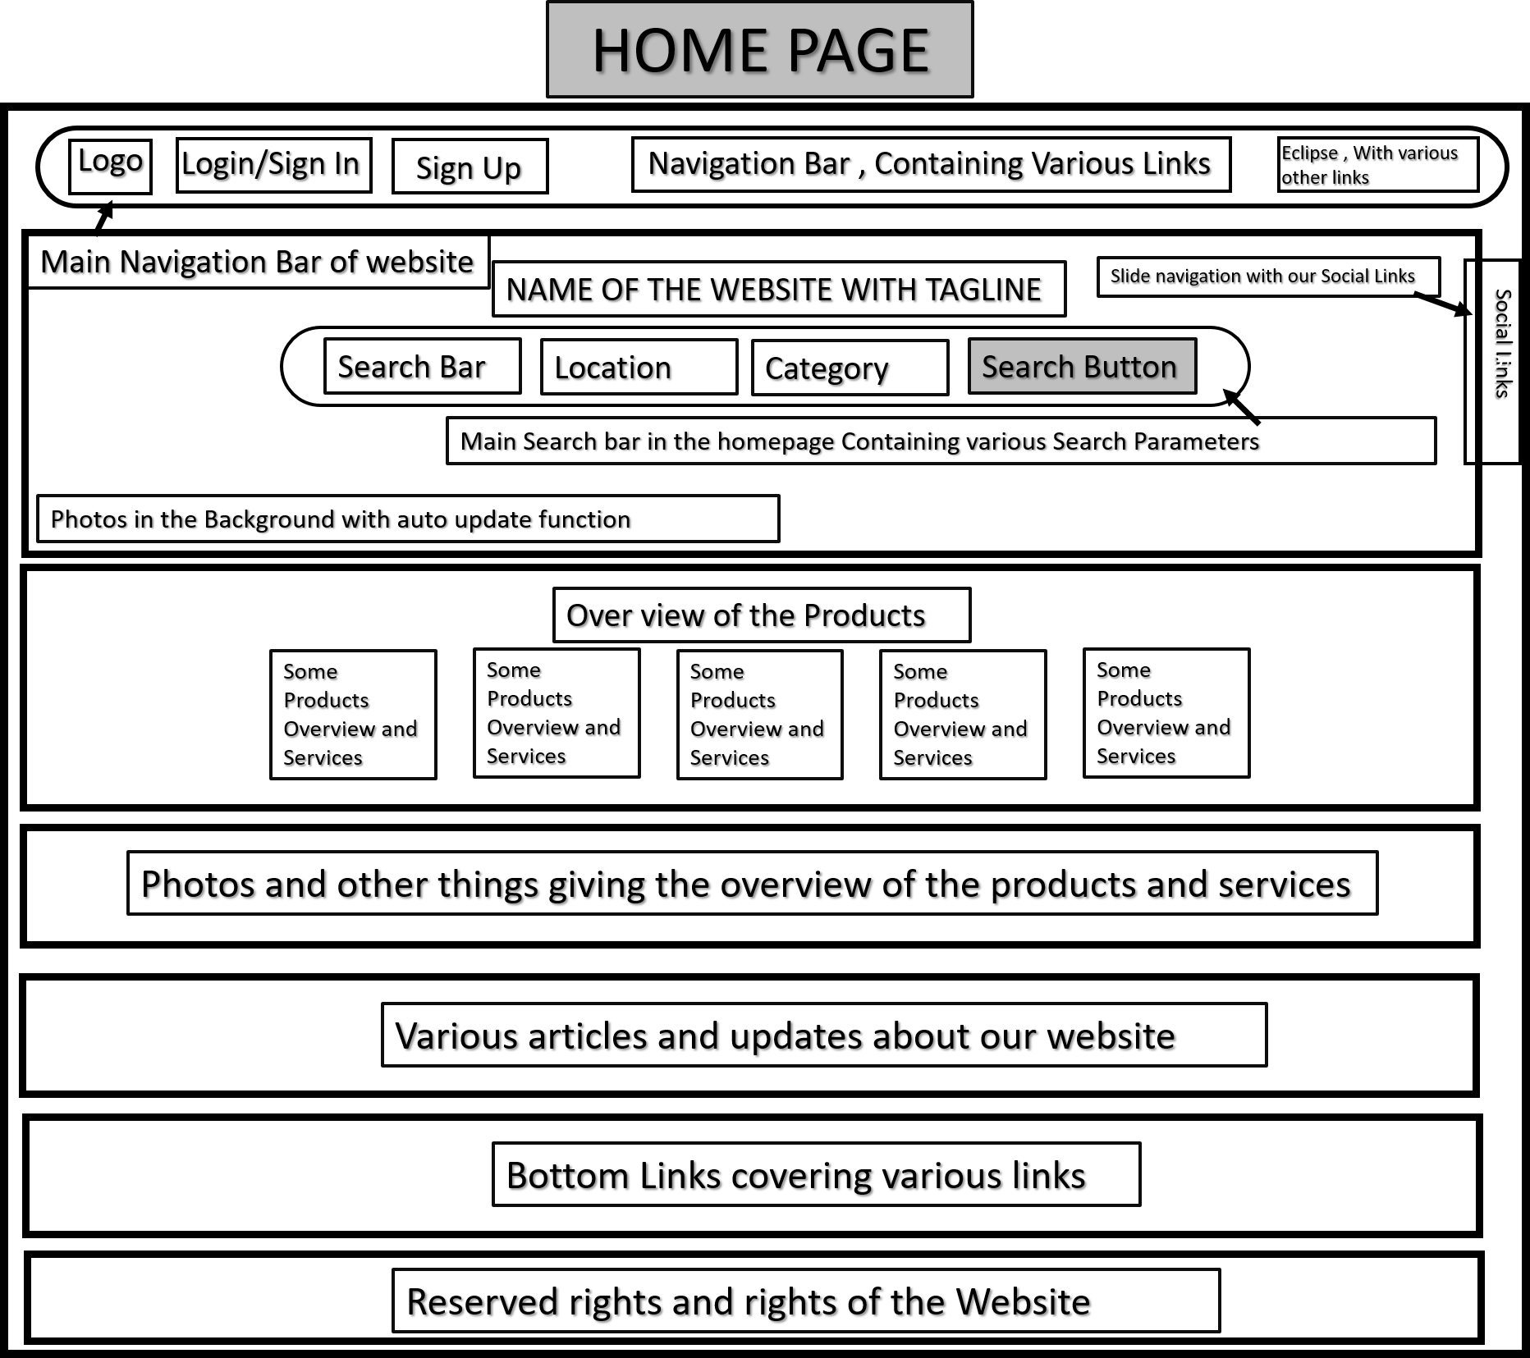

##### 1.3.2 Working of the Website Flow Diagram

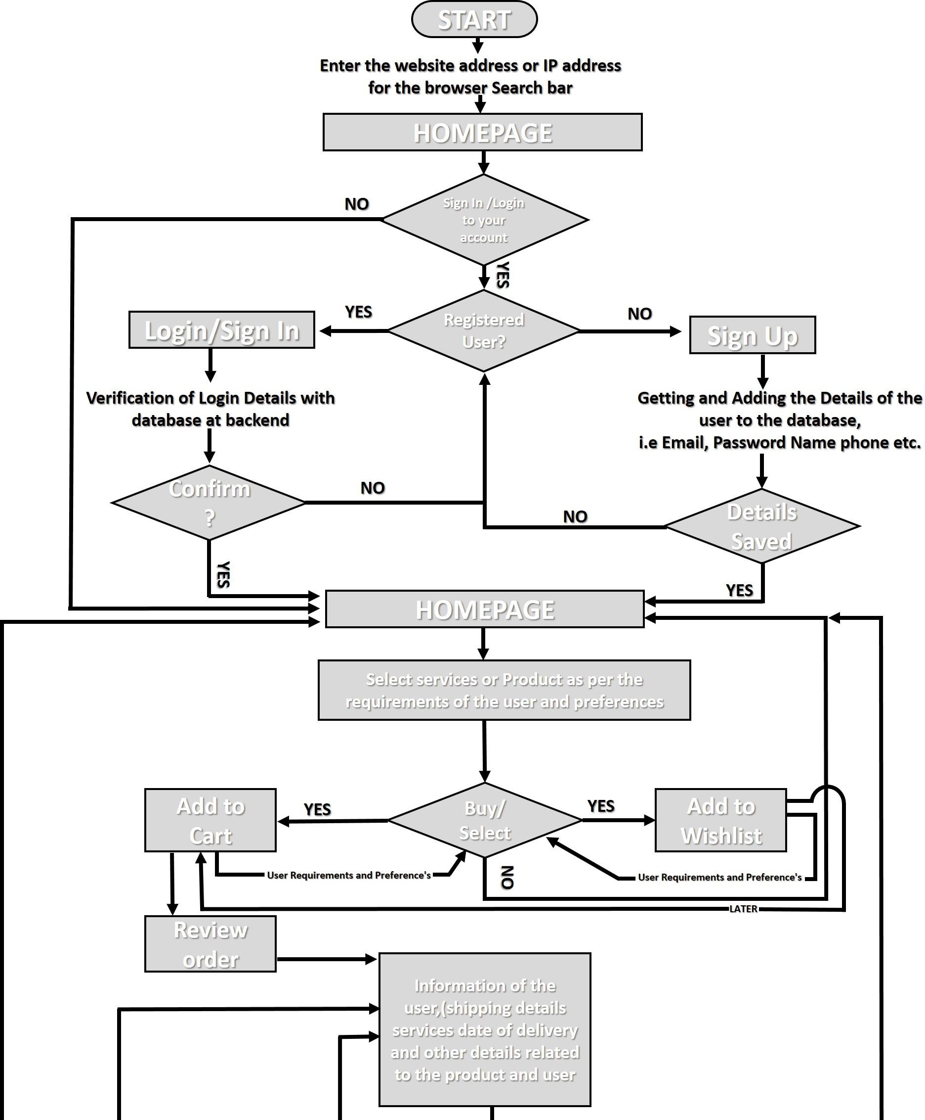

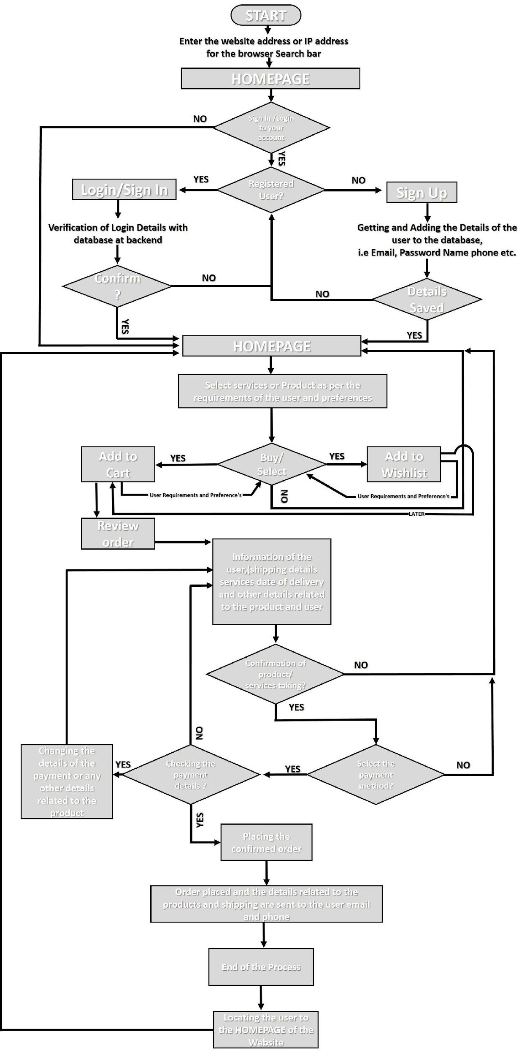

* + 1. **1.3.3 Detailed Layout of the Website**

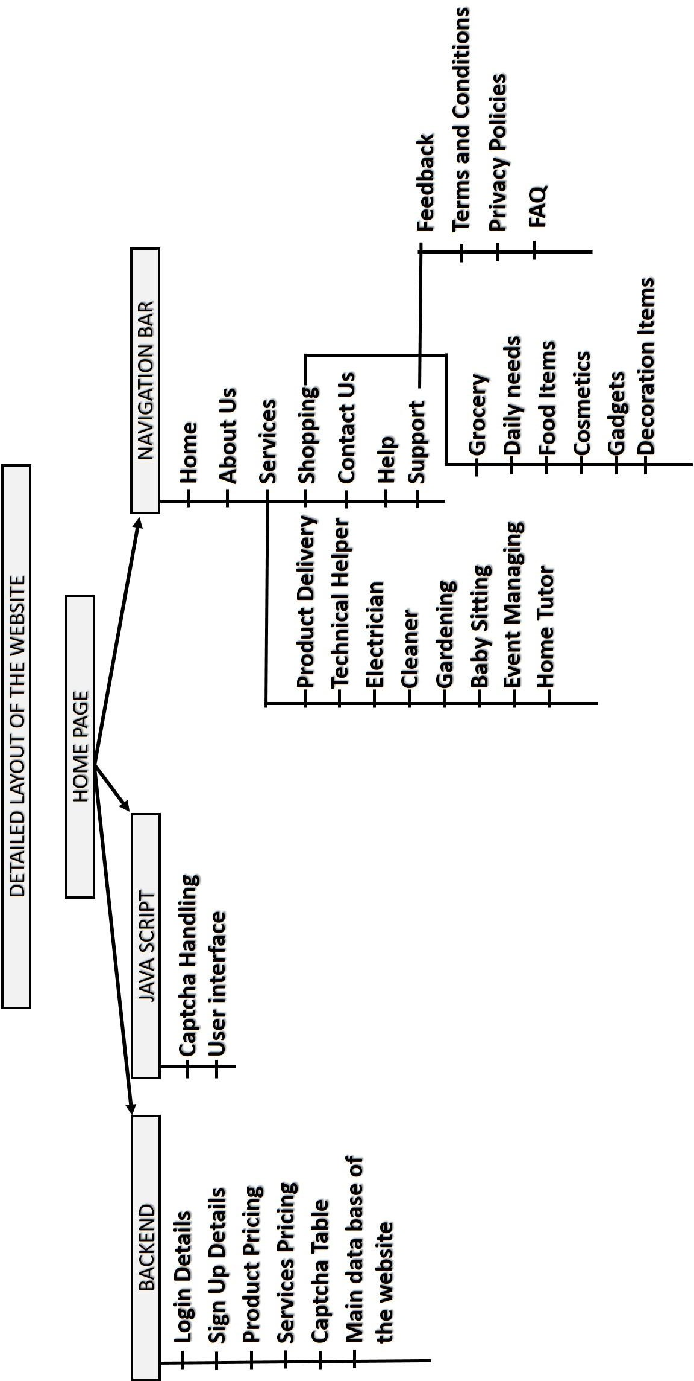

##### 1.3.4 ER- Diagram of the Backend Database

**Internet Links:**

**REFERENCE**

1. <https://1000projects.org/projects/cse-projects-with-source-code>
2. <https://www.tutorialspoint.com/mongodb/index.htm>
3. <https://www.w3schools.com/html/default.asp>
4. <https://www.codecademy.com/catalog/language/javascript>
5. <https://www.coursera.org/learn/server-side-nodejs>

Books:

* + - * 1. HTML & CSS: Design and Build Web Sites (By: John Duckett)
        2. Learning Web Design (Book by Jennifer Niederst Robbins)
        3. JavaScript and jQuery Interactive Front-End Web Development (Book by David McFarland)

**ABOUT DESIGNERS**

**TheStartUp DESIGNERS**

We have started our journey with designing various websites in our projects.

We aim to give our best in every project we are assigned with. Hope you will like

our work and provide us with good feedback which will give us the Motivation

to do our best in our upcoming projects.

**TheStartUp DESIGNERS team includes:**

* Charanjeet Singh Sidhu

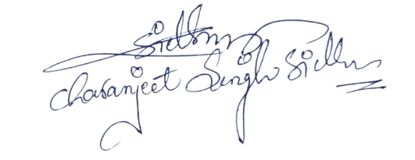

* Deepak Kumar

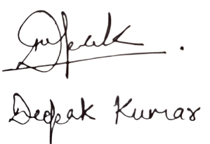

* 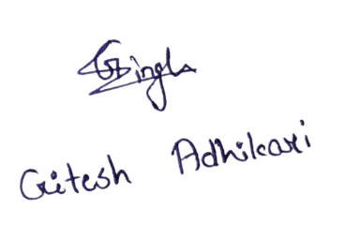Gitesh Adhikari

* Vijay Bhat

